**Department of Computer Science and Engineering**

**University of Liberal Arts Bangladesh**

**Mid-Term Examination (Summer 2020)**

**Course: Introduction to Computer Studies (CSE 101)**

**Section: 7 --- Duration: 1 Hour**

**______________________________________________________________________________________**

**Name:** John/Jane Doe **ID:** #########

**ANSWER TO THE QUESTION No. 1**

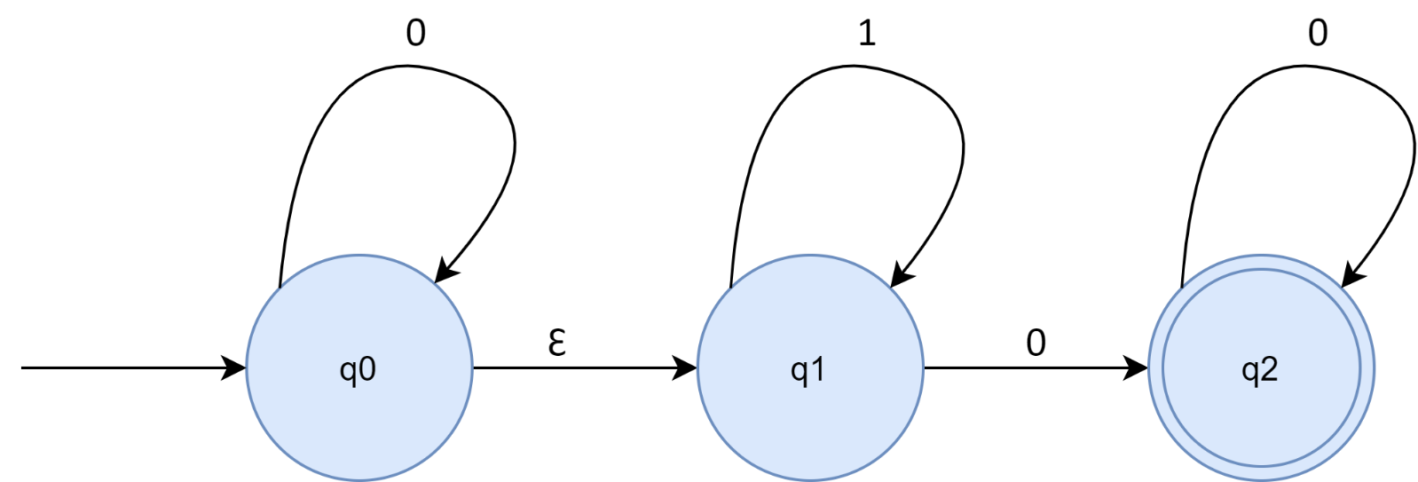

**ANSWER TO THE QUESTION No. 2**

[insert image(s) here]

**ANSWER TO THE QUESTION No. 3**

[insert image(s) here]

**ANSWER TO THE QUESTION No. 4**

[insert image(s) here]